Running Jupyter Notebook on Soil Classification

1. Sign in to <https://notebooks.azure.com/> using your UTexas email account.
2. Clone the project on soil classification by visiting <https://notebooks.azure.com/elmohtar/projects/soil-classification> and clicking on the clone button.

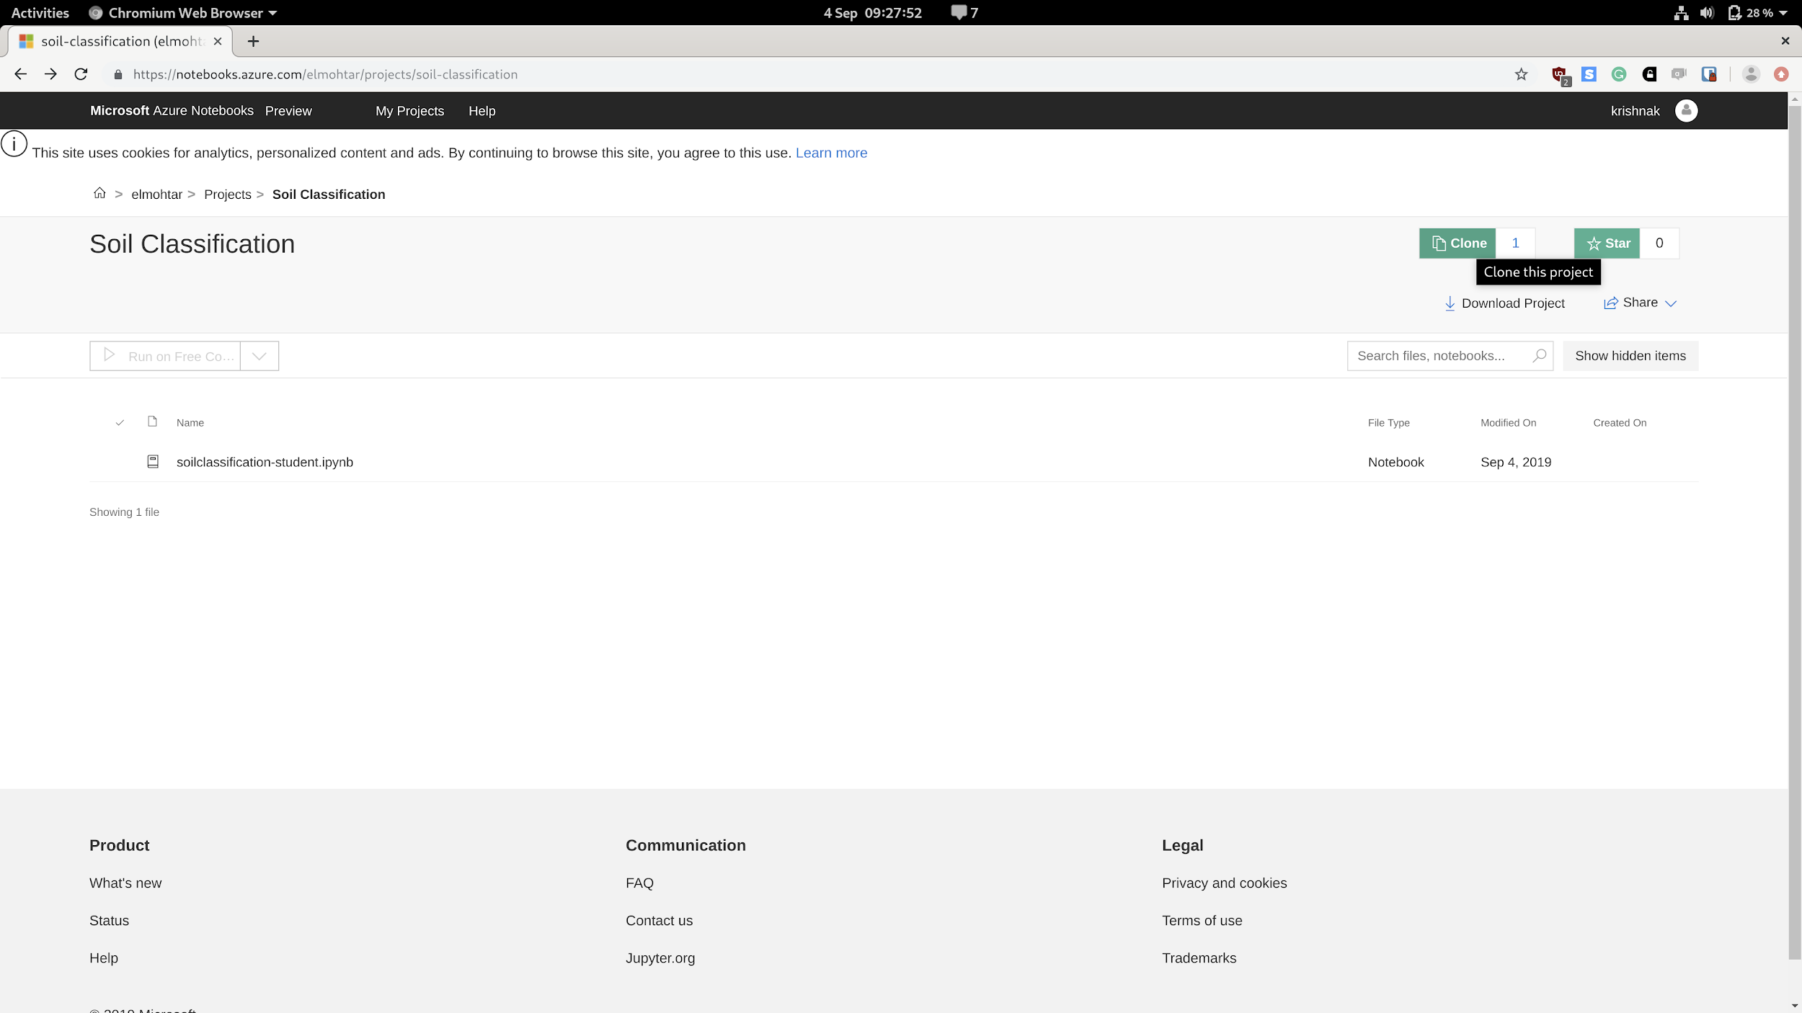

1. Clicking on the clone button will copy the soil-classification project to your My Project directory. Please ensure that you do NOT click on the public option when cloning this project.

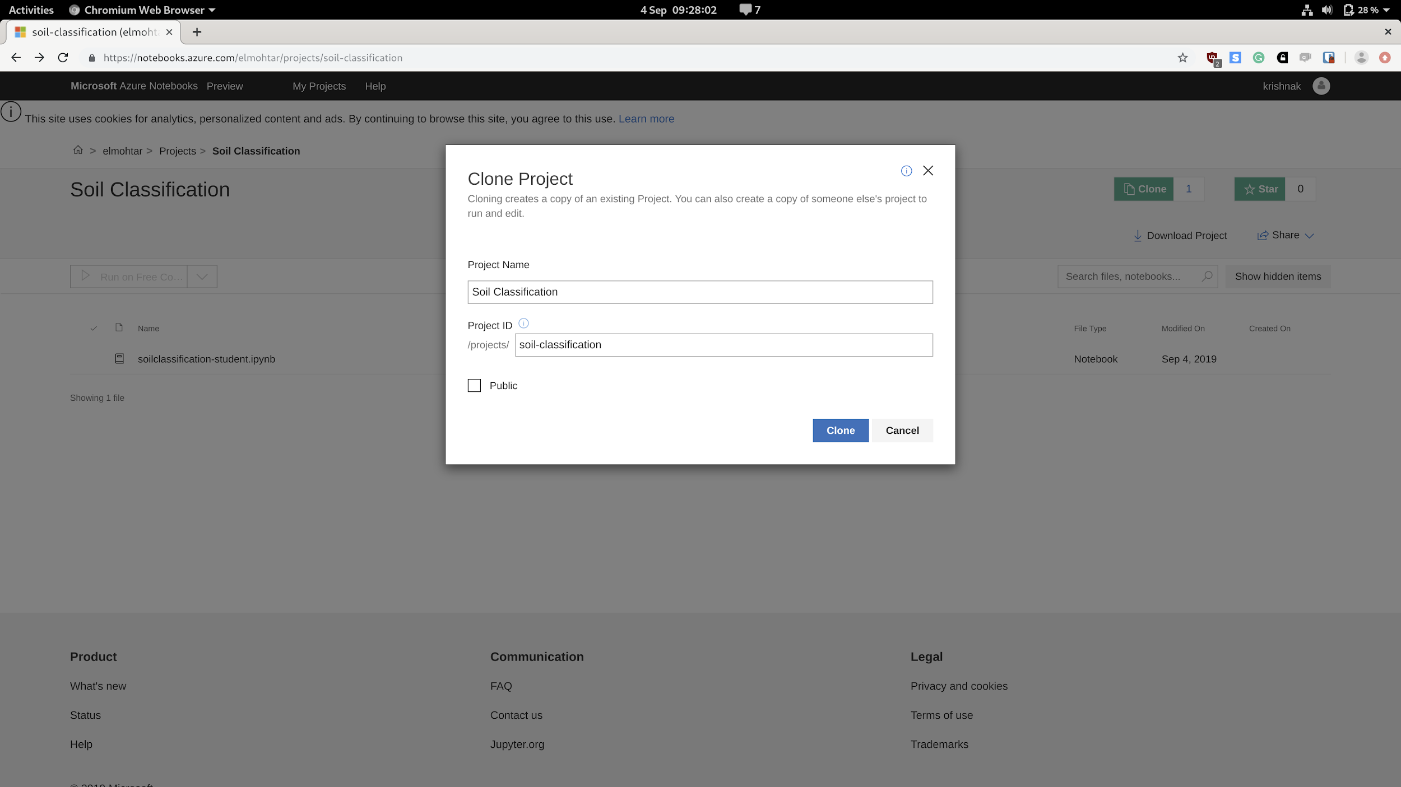

1. Once copied to your project, double click on the `soilclassification-student.ipynb` file in the project folder. This will open the project. To run click on the “Run” button or Ctrl + Enter or CMD + Enter as shown below

